**Experiment No 11:**

Perform various operations on a linked list

**Aim:** A program for various operations on a linked list.

**Theory:**

**Algorithm:**

**Insertion into a linked list**

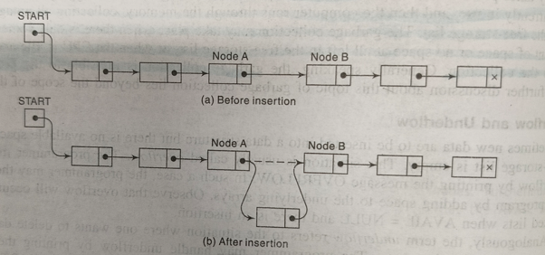

**LIST(INFO,LINK,START,AVAIL)**

Three pointer fields are changed as follows:

1.The next pointer field of node A now points to the new node N, to which AVAIL previously pointed.

2.AVAIL now points to the second node in the free pool,to which node N previously pointed.

3.The nextpointer field of node N now points to node B, to which node A previously pointed.

**Insertion at the beginning of a list**

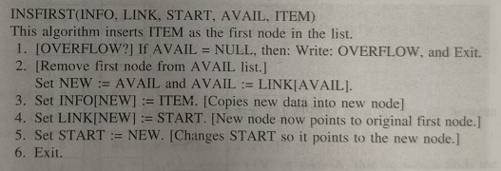

**Inserting after a given node:**

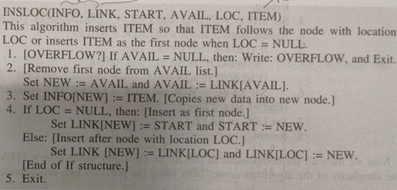

**DELETION FROM A LINKED LIST**

**LIST(INFO,LINK,START,AVAIL)**

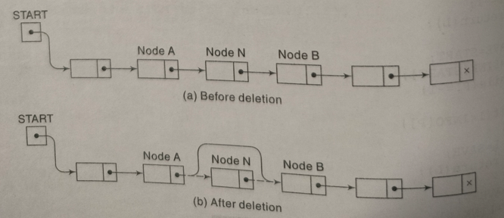

When a node N is deleted from list,it will immediately return its memory space to the AVAIL list.For easier processing,it will be returned to the beginning of the AVAIL list.

Three pointer fields are changed as follows:

1.The nextpointer field of node A now points to node where node N previously pointed.

2.The nextpointer field of N now points to the original first node in the free pool,where AVAIL previously pointed.

3.AVAIL now points to the deleted node N.

**Deleting the Node following a given Node.**

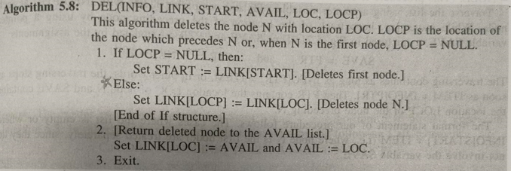

**PROGRAM: [Write program to insert into a linked list and delete from a linked list]**

**OUTPUT:**

**CONCLUSION:**